

New Client Intake Form
Name_________________________ Phone #__________________
Address_____________________________________________________________________________________
Email _______________________Birthdate___________ Referred by____________________________
Concerns
What concern(s) would you like to focus on in this session?

Current Medications and Supplements:
Please include both prescribed and natural products.
Medical History:
Please include all present and past diagnoses.
Stacy Green is not a physician or psychologist, and the scope of his/her consultation services does not include treatment or diagnosis of specific illnesses or disorders. If you, the client, suspect you may have an ailment or illness that may require medical attention, then you are encouraged to consult with a licensed physician without delay. Any mention of drugs in the course of consultation is only for the purpose of providing a complete history of drugs that the client is taking and not for Stacy Green to judge the appropriateness of the medication. Any change in prescription or dosage is a decision the client makes with his or her physician.

Rather than dealing with treatment of disease, Stacy Green focuses on wellness and prevention of illness through the use of non-toxic, natural nutritional therapies to achieve optimal health. As a certified nutrition consultant, Stacy Green primarily educates and motivates clients to assume more personal responsibility for their health by adopting a healthy attitude, lifestyle, and diet.

While people generally experience greater health and wellness as a result of embracing a healthier attitude, lifestyle, and diet, Stacy Green does not promise or guarantee protection from future illness.

The client, for himself (herself) and on behalf of his (her) executors, administrators, heirs and assigns, does herby expressly release, discharge, waive, relinquish, and covenants not to sue Stacy Green for such claims, demands, injuries, damages or cause of action, with respect to use of Stacy Green’s, programs and services.
Client’s Signature__________________________________Date__________
Symptom Survey
Nasal/Sinuses  __ Post Nasal Drip  __ Sinus Pain  __ Runny Nose  __ Stuffy Nose  __ Sneezing | Mouth/Throat  __ Sore Throat  __ Swelling of lips/tongue  __Gagging/Throat clearing  __ Have you had a major dental  Infection?  __ Bleeding gums  __ Use of conventional mouth  wash | Circle teeth with previous root canals  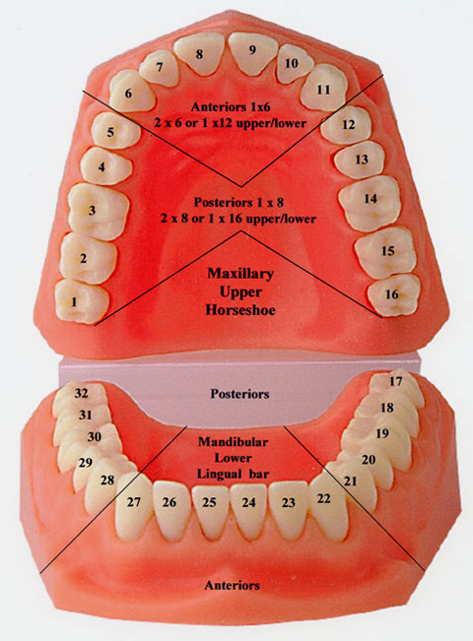
Head/Ears  __ Headache (any kind)  __ Migraine(diagnosed)  __ Ear Infection  __ Ringing in the ears  __ Itchy ears | Lungs  __ Wheezing  __ Chest Congestion  __ Non-Productive Coughing  __ Productive Coughing | Cardiovascular  __ Irregular Heartbeat  __ High Blood Pressure  ___ pvc’S  ___A fib  __ heart block
Skin  __ Blemishes, acne  __ Rashes, hives  __ Eczema  __ “Rosy” cheeks | Urinary  __ Increased Urinary Frequency  ___Painful Urination  ___ Foot pain first thing in the  morning | Digestive  __ Heartburn/Reflux  __ Stomach Pain/Cramps  __ Intestinal Pain/Cramps  __ Constipation  __ Diarrhea  __ Bloating Sensation  __ Gas  __ Nausea or Vomiting  __Painful Elimination  __ Diverticulitis
Musculoskeletal  __ Joint Pain/Aching  __Stiff Joints  __ Muscle Aches  __Stiff Muscles  __ Scoliosis | Emotional  __Depression (hopelessness)  __Anxiety(uneasiness)  __Mood swings  __ Irritability  __ Forgetfulness  __Lack of concentration/ focus  ___ Post partum depression | Sleep  __ Difficulty Falling Asleep  __ Awaken During the Night  If so, when?______  __ Difficulty Waking

Allergies/Sensitivities  ___ Sulfa drugs  ___ Sulfites in wine  ___ Penicillin  ___Gluten  ___ Dairy | Sympathetic/Parasympathetic/  Vagus Nerve  ___Dizziness  ___Fatigue  ___ Fear  ___ Concentration difficulties  ___ Head, neck, jaw pain  ___ Digestive issues | Tongue Tie Assessment  ___ Nightmares  ___Can’t sit still  ___Tightness in neck/upper shoulders  ___ Were you unable to nurse as a  baby?
Fascia Assessment  ___ Have you ever had an auto/bike  accident, bad fall or injury?  ___ Have you had pain unrelated to  the injured area after that  accident? | Past Bloodwork  ___ Iron deficiency  ___ Iron overload  ___ Felt great after donating blood  ___ Vitamin D deficiency  ___ Other irregular bloodwork  If so, what? | Hormones  ___ Heavy menstrual periods  ___ PMS  ____ hot flashes  ____ low libido
Your gifts

__ perceiver

__ servant

___teacher

___ giver

___ leader

___mercy

___ encourager

